People’s committee  _____________  Commune/Ward: Tho Thanh  District: Yen Thanh  Province/City: Nghe An | Socialist republic of Vietnam  Independence – Freedom – Happiness  ______________  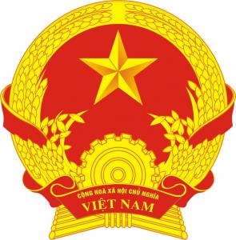 | Form BTP/HT-2006-KS.1.a  Nº :  Book Nº:

birth certificate
(COPY)

Full name : HO SY TRONG Sex: Male
04/2006 (Decision No. 01/2006/QD-BTP) XBTP
Date of birth : 20-10-1994 (The twentieth day of October, Nineteen ninety four)
Place of birth : Tho Thanh – Yen Thanh – Nghe An
Ethnic group : Kinh Nationality : Vietnamese
Native place : Tho Thanh – Yen Thanh – Nghe An
Full name of Father : HO SY TINH
Ethnic group : Kinh Nationality : Vietnamese
Full name of Mother: NGUYEN THI THE
Ethnic group : Kinh Nationality : Vietnamese
Full name of Declarant: NGUYEN THI THE
Relationship with the person declared: Mother

Registrar  (Signed)  Nguyen Van Quy | Registered on  On behalf of People's Committee  Chairman  (Signed)
Copied from birth registration book
August 10th, 2006
chairman
(Signed and sealed)
Ta Hao Quang

